**LINUX COMMANDS**

2.ll

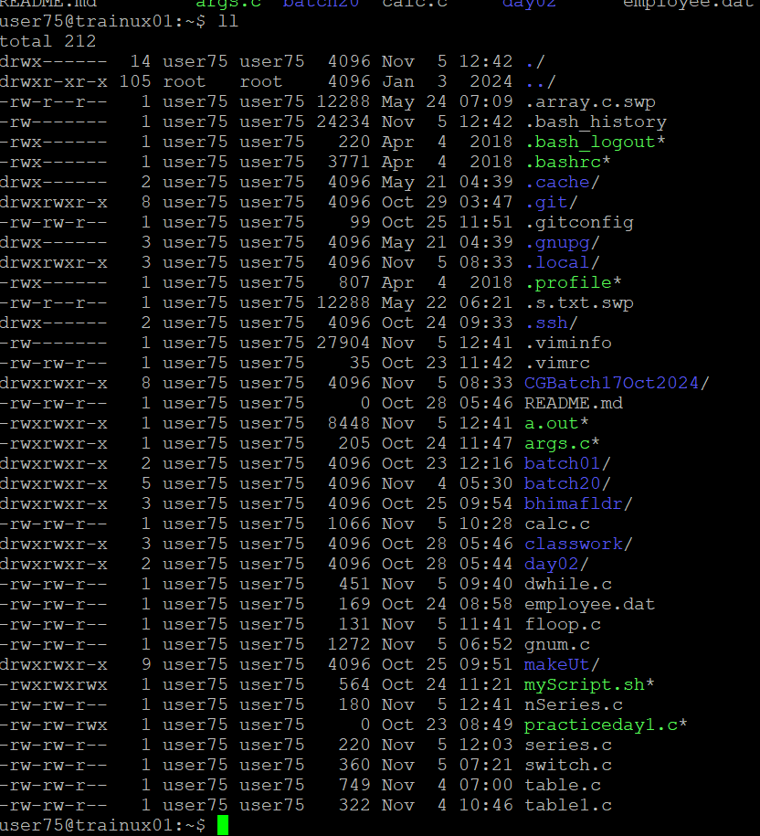

3.(a) mkdir d1(make directory)

(b)to create a sub-directory d2 in d1:

(c) change to directory d2

d. create an empty file “f1.txt”

touch f1.txt



e. display the contents of “f1.txt”

cat f1.txt

f. view the contents of d1 from current directory d2

cat d2/d1

4.Use the ls command with its options. How will you identify directories from the listing?

i.ls-l( -l gives the long listing of files and directories)

ii. ls-a( -la gives all the files including hidden files)

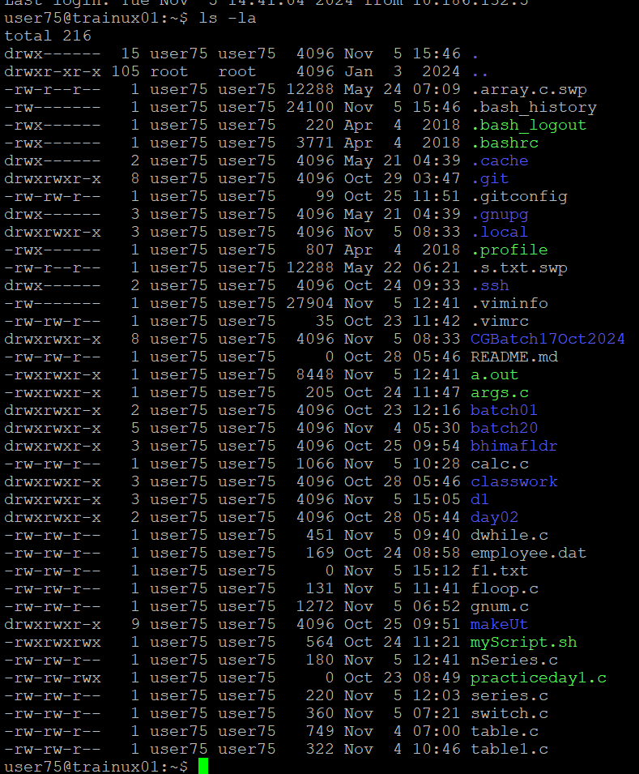

The d at the beginning of the permissions indicates that the entry is a **directory**.

**5.Use ls to do the following**

**a. List files with single character names**.

ls -1

**b. List hidden files also. [ Note : Hidden files are files having name started with a “.”**

ls-a



**c. Suppose there are files tb1.1, tb2.1, tb3.1, ….tb10.1. Write command to list all the files [Hint: use wild card characters]**

ls tb*.1

**6. Write the command to list all files in descending order of their size.**

ls -lsr

**7.Suppose there are files temp1, temp2, temp3. Write command to remove the files without listing them explicitly**

rm temp*

**8. Which command is used to list top few lines in the file?**

head table.c

**9. Create a directory “testdir”**

mkdir testdir

**10. Use cp command to do the following**

**a. Copy the file tb1.1 (created above) in the same directory**.

Cp tb1.1 testdir

**b. Write a command to copy all the files i.e tb1.1,tb2.1,tb3.1,…..tb10.1 in a new directory –“new”**

cp tb*.1 new/

**c. Create a subdirectory in new in named“new1”.**

mkdir new1

Cd new1

**d. Write a command to copy selectively only tb2.1, tb6.1, tb7.1 and tb10.1 in the directory new1**

cp tb*.1 new1/

**e. Write a command to copy the entire directory “new” to a directory “newprogs”. [Note : use the –R option of “cp” command ]**

cp -R new/ newprogs/

**11. Find out the difference between**

**a. ]“mv” & “cp”**

mv- -- When you move a file to another directory, the file is **removed** from its original location and placed in the new location.

Cp--- It creates an **exact copy** of the source file(s) at the destination location. The original file is **left unchanged** in its original location.

b. “rm”, “rmdir”

**rm (Remove Command)---**

rm removes files. It does not remove directories unless specified.

**rmdir (Remove Directory Command)**

It only works on empty directories. If the directory contains any files or other directories, rmdir will fail and return an error.

c. “mkdir” and “mkdir -p”

**mkdir (Make Directory Command)**

The mkdir command is used to create a single directory.

**mkdir -p (Make Directory with Parent Command)**

1. The mkdir -p command is used to create a directory and any necessary parent directories that don't already exist.
2. The -p option stands for "parents", and it allows mkdir to create parent directories in the specified path if they don't exist. If any of the parent directories in the specified path are missing, mkdir -p will create them automatically.

12. Use a single command rmdir once to remove “testdir” and all its sub directories and files created above.

**rm -rf testdir**

13. Which command is used to get the manual information of a command?

14. If you are not able to change to a directory what could be the likely cause?

1. Directory Does Not Exist
2. If we mistyped the directory name or the path.
3. If we do not have the necessary permissions to access the directory.

15. Explain the differences among the following commands:

a. cd /

b. cd ..

c. cd

d. cd ../..

1. Changes the current directory to the **root directory** (/).
2. Moves the current directory **up one level** to the parent directory.
3. Goes to the mentioned directory
4. Goes to the parent’s parent directory